**Specifications Compliance Tool**

**User Guide**

**Eli Lilly and Company**

**Introduction**

This document provides guidance for using the Specification Compliance Tool.

This guide will be helpful for anyone needing to perform compliance checks on study specifications. It is assumed that anyone doing this work will have knowledge of using SAS macros, and the ability to run SAS in AWE or CLUWE.

The Specification Compliance tool is a SAS macro that generates compliance reports on configured study specifications which are reviewed to ensure compliance with Eli Lilly’s implementation of CDISC SDTM & ADaM standards.

Creation and review of specifications compliance reports prior to generating production data deliverables is a required task in the Lilly dataflow process.

This user guide describes what is necessary to:

* Execute compliance checks for configured SDTM or ADaM study specifications based on CDFM standards.
* Execute compliance checks for configured SDTM or ADaM study specifications based on a Study Level Definition (SLD).

This guide will not cover the requirements for review of specifications compliance reports. Discuss with your SDTM/ADaM consultant as needed.

Documentation on the usage of this macro is found at this link:

<http://lillynetcollaboration.global.lilly.com/sites/vct/SitePages/Home.aspx>

**Process Flow**

The high-level process flow is shown below.

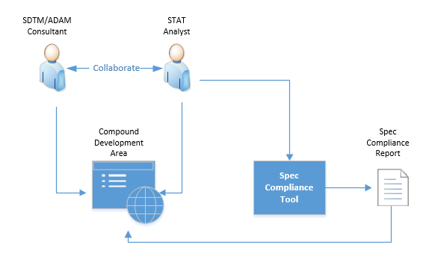

The SDTM / ADAM Consultants and Stat Analyst work in collaboration to configure the SST and validated.

* SDTM/ADAM consultants create the initial SST and upload it to the Compound Development Area (Development Templates) in Document center
* The Stat Analyst will acquire the SST and configures it.
* The Stat Analyst will validate the configured SST using the spec compliance tool.
* The report generated by the tool will be reviewed by the Stat Analyst and further updates will be made to the SST (with help from SDTM/ADAM consultants) if needed untill all issues are resolved.
* All reports and SSTs must be stored in the Compound Development Area

**Location of Tool:**

The spec compliance tool has been developed, tested and validated for AWE and CLUWE. The macro is available in the below locations:

|  |  |
| --- | --- |
| **Environment** | **Macro Path** |
| AWE | \\MANGO\sddext.grp\SDDGENERAL\macro_tools |
| CLUWE | /lillyce/prd/general/rums/macro_library/sct |

**Usage**

Using the Specifications Compliance Tool requires setting up the macro library, and then calling the macro, which references the compliance rules file.

Syntax:

options sasautos=(sasautos “<Macro Path for environment>”);

%spec_compliance_check(

specname=*<REQUIRED location/name of the study specifications or SLD XLSX file>*,

sstname=*<OPTIONAL location/name of the Study Specifications Template (SST) XLSX file>*,

specmodel=<*SDTM* or *ADAM*>,

output=*<location/name of the output XML file>*

);

Full list of Parameters:

|  |  |  |  |
| --- | --- | --- | --- |
| **PARAMETER** | **REQUIRED / OPTIONAL** | **DEFAULT** | **DESCRIPTION** |
| SPECNAME | Required |  | Full path of StudySpec / SLD to run checks on. |
| SSTNAME | Optional |  | Full path of SST to compare StudySpec against. |
| SPECMODEL | Optional |  | Specify ADAM or SDTM |
| OUTPUT | Optional | Same location as StudySpec | Full path of output file |
| STUDYNAME | Optional |  | Name of study to include in the output |
| DEBUGMODE | Optional | NO DEBUG | Capability to add debug parameters |
| PRODMODE | Optional | Y | Y / N – Runs the Prod or QA version of the tool. |

**The OPTIONS statement:**

The user needs to point the SASAUTOS at the location of the SPEC_COMPLIANCE_CHECK macro.

Example for AWE:

%let maclib = \\MANGO\sddext.grp\SDDGENERAL\macro_tools;

options noquotelenmax nocenter sasautos=(sasautos "&maclib") mautosource nomprint;

**SPECNAME Parameter:**

The SPECNAME parameter is required and will be the filename and location of a MS Excel workbook (*.xlsx) containing configured SDTM or ADaM study specifications for either:

1. one or more domains/datasets based on CDFM standards
2. one domain/dataset based on a Study Level Definition (SLD)

Files of either type should be based on CDFM templates or may be incompatible with the macro.

The location and filename should NOT be enclosed in quotes. For example:

specname=&studypath.\specs\ADAM_StudySpec_Batch1.xlsx

**SSTNAME Parameter:**

The SSTNAME parameter is required when the file used for the SPECNAMEparameter contains study specifications based on CDFM standards (i.e., type ‘a’ in the section above).

The value for SSTNAME will be the filename and location of a MS Excel workbook (*.xlsx) containing the Study Specifications Template. Standards for all domains/datasets in the study specifications should be included.

Execution of the SPEC_COMPLIANCE_CHECK macro without specifying a value for the SSTNAME parameter will only provide a partial set of compliance checks, but note that review of checks that compare study specifications to CDFM standards (via the SST) are a required component of the dataflow process.

A value for SSTNAME is not required (nor meaningful) when the file used for the SPECNAME parameter is for a Study Level Definition.

The location and filename should NOT be enclosed in quotes. For example:

sstname=&studypath.\specs\ADaM_SST.xlsx

**SPECMODEL Parameter:**

The SPECMODEL parameter is optional, but strongly recommended, and simply tells the program whether the provided specs are based on the SDTM or ADaM model. If this parameter is provided, then only the values SDTM and ADaM are valid. If this parameter is omitted, then the program will attempt to discern the value on its own.

Example:

specmodel=SDTM

**OUTPUT Parameter:**

The OUTPUT parameter is optional. The value for the OUTPUT parameter will be the full path of an XML file containing the compliance check results. If this parameter is not passed, the tool will generate the output file in the same location as the studyspec. The name of the output file will be : <SPECNAME>_report_<YYYYMMDD>.xls

When passing the parameter, the location and filename should NOT be enclosed in quotes, as shown below.

output=&studypath.\specs\SCT_ADAM_Batch1.xml

NOTE: The possible output formats are .xml or .xls.

**STUDYNAME Parameter:**

The STUDYNAME parameter is just a plain text parameter that does nothing more than include the name of the study in the report. If this parameter is not passed, the output doesn’t have the name of the study.

Example:

studyname=F3Z-MC-IOQL

**DEBUGMODE Parameter:**

The DEBUGMODE parameter is a provision to pass debugging parameters to the macro like mprint symbolgen, etc. By default, all debugging parameters are disabled.

Example:

debugmode=mprint symbolgen

**PRODMODE Parameter:**

The PRODMODE parameter chooses the prod / qa version of the macro to execute. By default, the prod version of the macro is used. If prodmode=N, then QA version of the macro is executed.

Example:

prodmode=N

### Example Macro Calls

#### Example Macro Call #1: Compliance Checks on a SLD

dm 'clear log; clear out';

%let maclib = \\MANGO\sddext.grp\SDDGENERAL\macro_tools;

%let studypath = ; *STUDYPATH will be the location of the users files;

options noquotelenmax nocenter sasautos=(sasautos "&maclib") mautosource nomprint;

%spec_compliance_check(

specname=&studypath.\specs\ADaM_ADEFF.xlsx,

specmodel=ADAM,

output=&studypath.\specs\SCT_ADEFF.xml

);

#### Example Macro Call #2: Compliance Checks on Study Specifications Created from an SST

dm 'clear log; clear out';

%let maclib = \\MANGO\sddext.grp\SDDGENERAL\macro_tools;

%let studypath = ; *STUDYPATH will be the location of the users files;

options noquotelenmax nocenter sasautos=(sasautos "&maclib") mautosource nomprint;

%spec_compliance_check(

specname=&studypath.\specs\ADAM_StudySpec_Batch1.xlsx, sstname=&studypath.\specs\ADAM_SST.xlsx,

specmodel=ADAM,

output=&studypath.\specs\SCT_ADAM_Batch1.xml

);

**Output from Specifications Compliance Tool**

The output file specified in the macro call will be an XML (*.xml) file formatted to open with MS Excel. If the user chooses, the report can be saved as an Excel file (.xlsx) upon opening the file and selecting ‘Save As…’.

The output file will contain up to five tabs, depending upon the issues found:

* Table Level Checks
* Variable Level Checks
* CT/VL Level Checks
* Rules
* Compliance Results

### Table Level Checks

This tab contains compliance results for checks done at the table level. If no issues were found, then this tab will not be created.

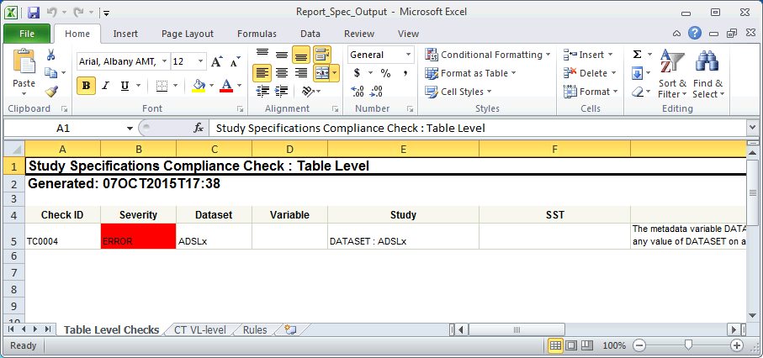

Note the color coding for the Severity flag which indicates the severity of the compliance check. Warnings will be highlighted in yellow, while errors will be highlighted in red.

### Variable Level Checks

The Variable Level Checks tab contains compliance results for checks done at the variable level. If no issues were found, then this tab will not be created.

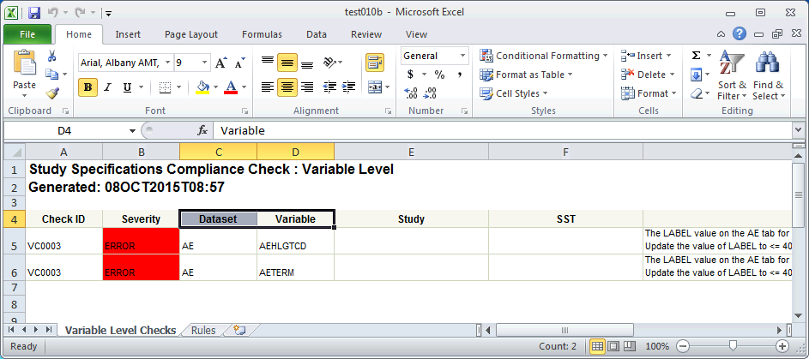

Note the color coding for the Severity flag which indicates the severity of the compliance check. Warnings will be highlighted in yellow, while errors will be highlighted in red.

### CT/VL Level Checks Tab

This tab contains compliance results for checks related to Controlled Terminology and Value Level Metadata. If no issues were found, then this tab will not be created.

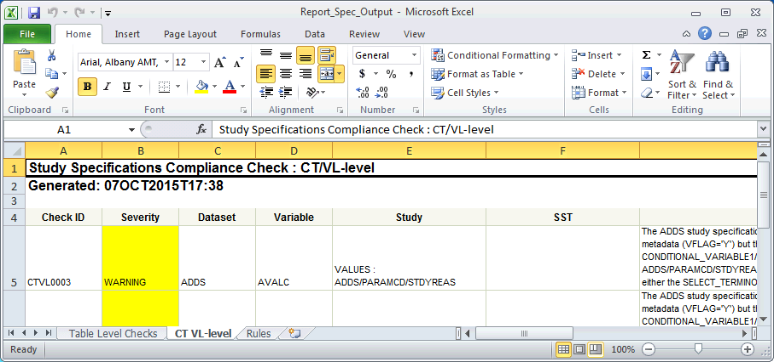

Note the color coding for the Severity flag which indicates the severity of the compliance check. Warnings will be highlighted in yellow, while errors will be highlighted in red.

### Rules Tab

This tab contains descriptions for the set complete set of compliance rules. This tab will be in the output every time. Note that this tab is provided for reference purposes

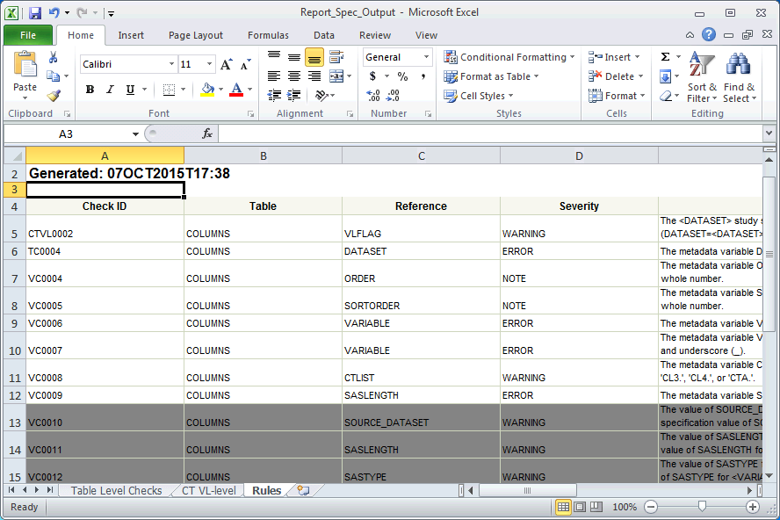

Rules that are not run will be displayed, but will be highlighted in grey.

### Compliance Results Tab

One other tab will be generated, only if there are no issues found. The Spec Compliance Result tab will simply announce that there were no issues found in any of the checks.

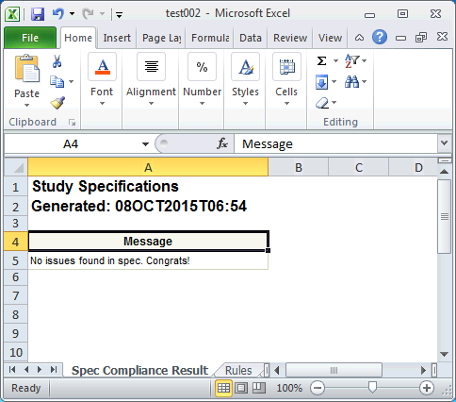

**Support and Troubleshooting**

In troubleshooting the tool, please follow these three steps:

Step One: Examine any messages for some clues as to what might be wrong, to see if you can fix the issue yourself.

Step Two: Talk with your colleagues to see if they have experienced the same issue.

Step Three: Check the FAQ section of the collab site:

<http://lillynetcollaboration.global.lilly.com/sites/vct/SitePages/Home.aspx>

Step Four: Submit a ticket at the above collab site.

Tickets submitted should see a response within 2-4 business hours. Requests for training and/or coaching can also be submitted using the ticket system.

**Enhancement Requests**

Enhancement request are always welcome from the users. If you have any request / suggestion, please submit a service request ticket on the Reusable Code site and it will be actively monitored.

<http://lillynetcollaboration.global.lilly.com/sites/vct/Lists/Code%20RequestHelp/Public%20View.aspx>

**Summary**

The Specs Compliance Tool is designed to ensure standardized data that can be efficiently coded and used with other tools. Following proper methods for making sure study specifications adhere to standards will help ensure that the data is correct, increase efficiency in development, and is usable by additional tools to create tables and TFL’s using standardized code. In addition, using this tool will minimize issues downstream when the data compliance checks are run.